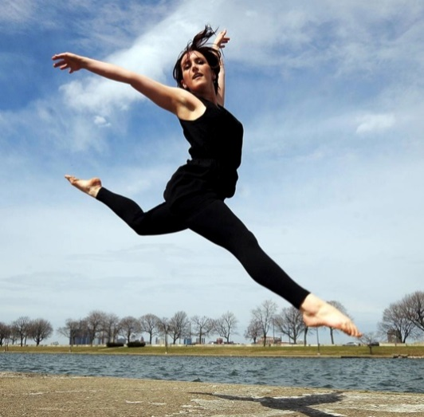
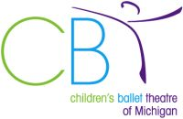

Join us for a Master Class with
Brighton Dance Festival Director,
Kathy King

on Saturday, July 13, 2019

10:00 am-12:00 pm for Dancers Ages 13-18: $30 per student
12:30-1:30 pm for Dancers Ages 8-12: $20 per student

Ms. King’s classes will include a jazz-based warm-up and across the floor. Plus, a contemporary jazz choreography combo to finish the class. The later class (designed for younger dancers) will be on a slightly slower scale.
“I love pushing students to step out of their comfort zone and build their confidence to try new ways of moving!” -Kathy King

Come join us at CBT’s Studio in Old Town
@1235 Center Street in Lansing!
To save your spot, register at www.cbtdance.org
Click on “Academy Classes” to register!
(This master class is open to all dancers – not just CBT members!)

